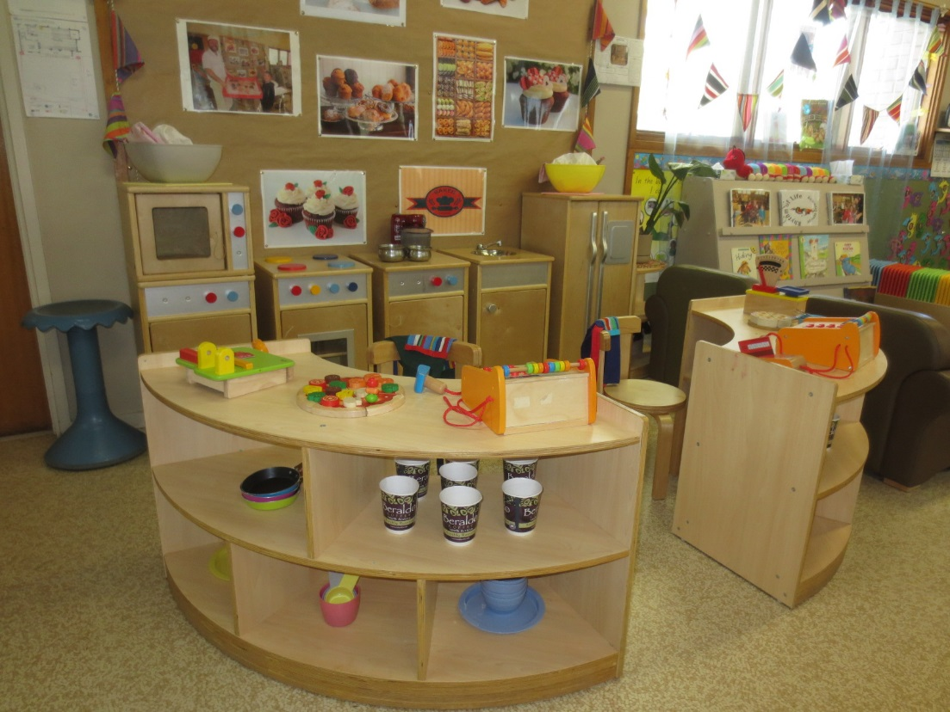

Join our Parent Advisory Group
It’s a great way to be part of your
kindergarten community.
Joining our PAG is a fantastic way for you to meet other families and to contribute to your child’s kindergarten experience.

Unlike a traditional committee of management, our PAG doesn’t have any service management responsibility as this is all handled by Shine Bright EYM. Our PAG’s role is to build meaningful connections between parents, educators and the local community.
Our PAG members will work together to shape a group that reflects their interests, available time, specialised expertise, cultural preferences, and needs.
Best of all, the amount of time you dedicate to the PAG is completely up to you. We encourage you to come along to our Annual Information Evening to find out more.

Please speak to your child’s Early Years Teacher if you have any questions.

