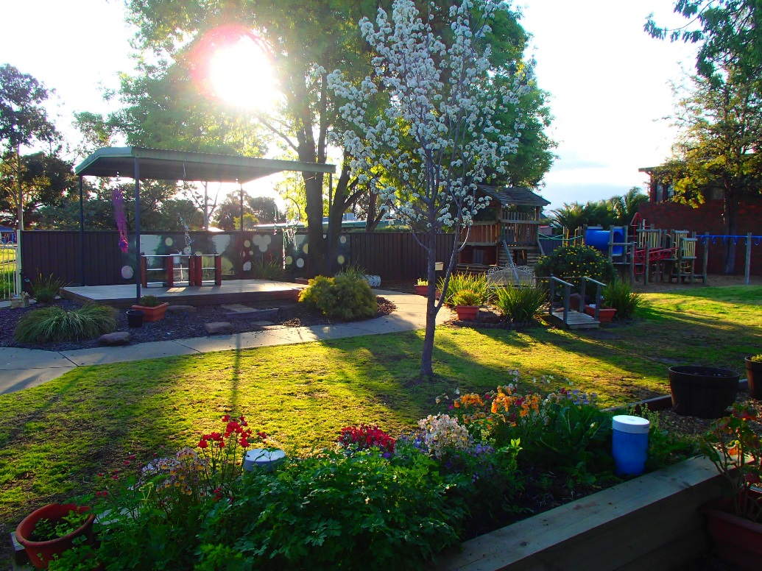

The Role of the Parent Advisory Group Convener
The PAG will usually meet at least four times a year and coordinate a range of events and activities that foster a sense of belonging for all families.
While the roles in the PAG can vary each year according to the strengths and interests of the current participating members, there is one important role that must be filled each year to ensure the group functions well. This role is The Convener.
The Convener is responsible for:
- Calling meetings
- Running the meetings (with an agenda if required)
- Ensuring meeting records are kept (i.e. Minutes/Notes – these can be delegated
to another member)
- Sharing information with PAG members and other families
- Liaising with Shine Bright EYM

To become the PAG Convener, simply volunteer your interest to your child’s Early Childhood Teacher. If there is not a parent member available to act as the PAG Convener, a Shine Bright staff member or educator will assume this role until there is a willing parent to take it on. Shine Bright educators greatly value the support of parents in convening and coordinating the Parent Activity Group. All parents are encouraged to participate in any way they can.

