Aboriginal Jewellery

This activity is looking at the different types of Jewellery that Aboriginal people would use. Some of these are modern types whilst others would be worn during ceremonies.

Please be aware that some of these activities will require the help of an adult.
Resources needed for each of the items will be mentioned for each item.
I would like to thank Uncle Rick Ronnan for making the gumnut necklaces and Simon Penrose for sharing his knowledge on YouTube for the making of Reed Necklaces

The following activities are included in this activity sheet –
- Gumnut Necklaces
- Reed Necklaces
- Nature Bracelets
We hope that you enjoy this activity!

Gumnut Necklaces –
Please note - Adult Supervision required – use of power tools
What you will need –
- Gumnut or similar
- String or wool
- Hair clip (folded fine wire can also be used)
- Feathers
- PVA (or craft) glue
- Drill with fine drill bit
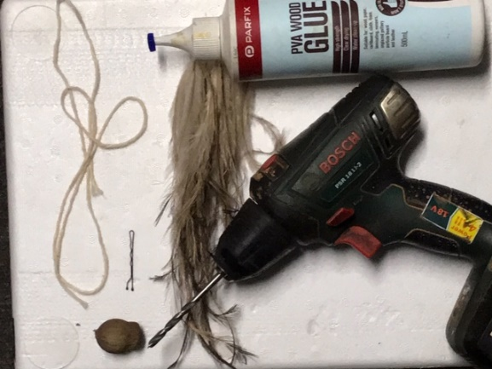
Step 1 – Drill hole into end of gumnut until all way through
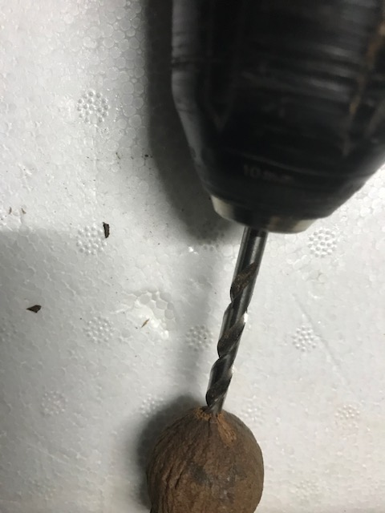
Step 2 – Using enough string to make a necklace, tie a knot in the string to make a loop.
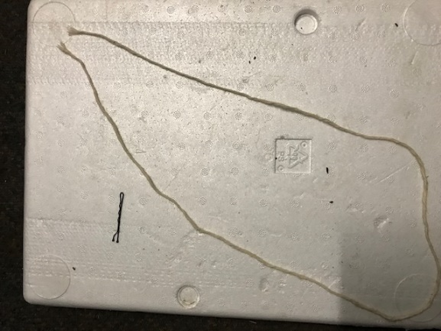
Step 3 – Using the clip or wire, thread the string through the hole in the gumnut, until the knot in the string is inside of the gumnut.
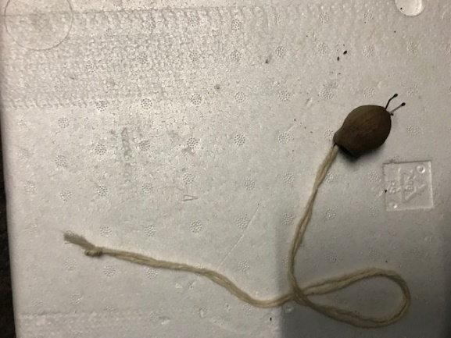
Step 4 – Gather some feathers together in a small bunch (we have used emu feathers, but any smaller feathers can be used).
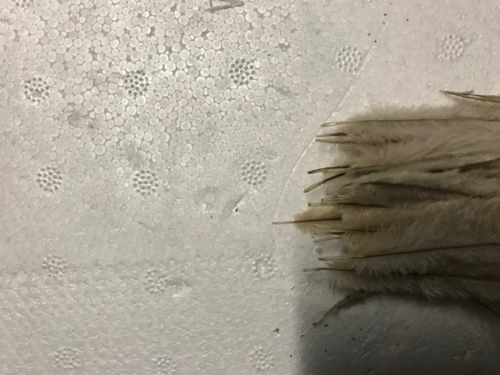
Step 5 – Place a small amount of glue into the hollow of the gumnut.
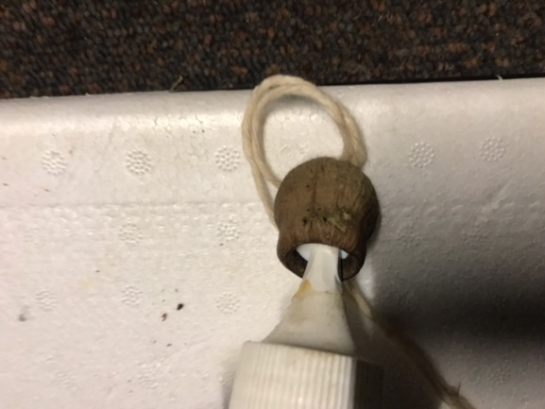
Step 6 - Push feathers into glue and allow for glue to dry.
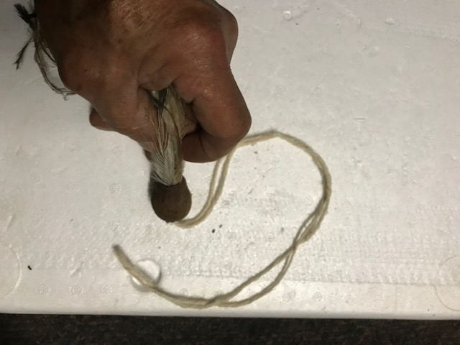
Your gumnut necklace is now finished. The gumnut can be decorated or left plain.
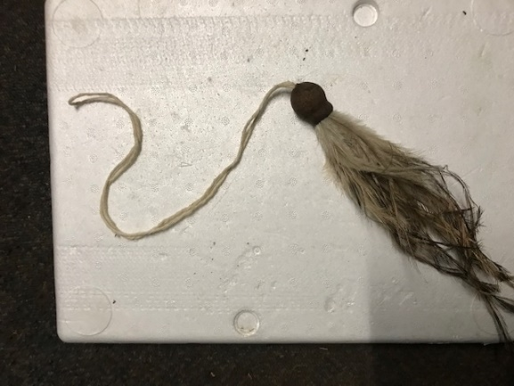

Reed Necklaces
Aboriginal people would have jewellery for many different reasons. One of the easiest to make is the reed necklace. In the YouTube clip below see Simon talk about different plants and their uses. One of the plants used to make necklaces is the Common Water Reed.
https://www.youtube.com/watch?v=TzI3Asp-cr8&t=656s
What you will need –
- String or Wool
- Straws, Macaroni or can make own rolled paper reeds. If making rolled paper reeds you will also need sticky tape or glue to secure paper. I have also used dowel to roll my paper around
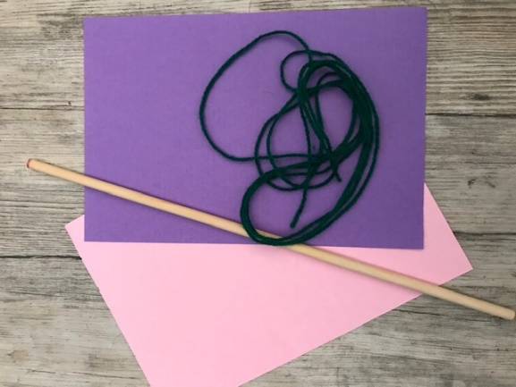
If making own reed with paper, roll paper around dowel. Secure ends with glue.
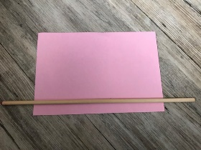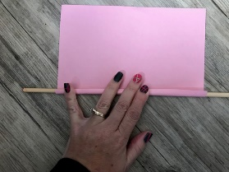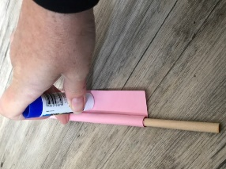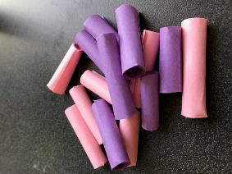
Cut straws/paper into approx. 2cm lengths. Thread onto string.
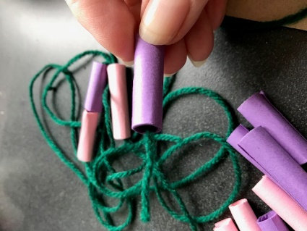
Tie ends of string together. Necklace is ready to be worn.
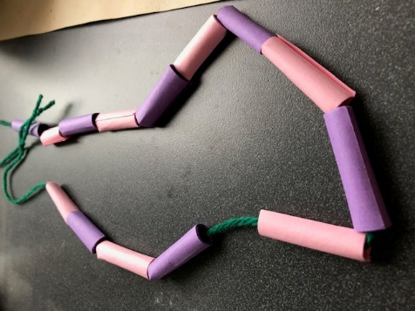
Pictures below are from Melbourne Museum collection - Reed Necklaces. Photos shared with permission from photographer – Kerri Douglas

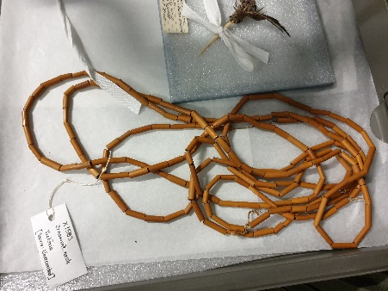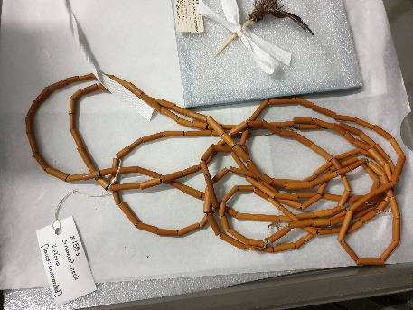
Links to the VEYLDF:
Outcome 1
Children have a strong sense of identity (Identity)
Outcome 2
Children are connected with and contribute to their world (Community)
Outcome 4
Children are confident and involved learners (Learning)

Developmental Areas
Physical
Emotional
Cognitive

