ATTACHMENT 3
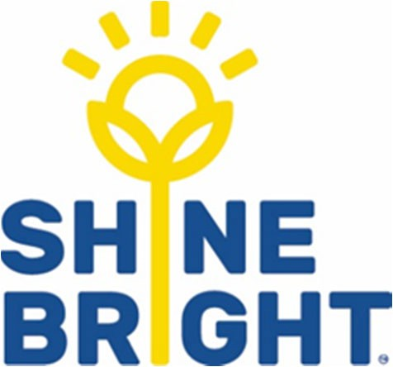

Enrolment checklist for children diagnosed with a medical condition

Item
A risk minimisation plan is completed in consultation with parents/guardians prior to the attendance of the child at the service, and is implemented including following procedures to address the particular needs of each child diagnosed with a medical condition.
Parents/guardians of a child diagnosed with a medical condition have been provided with a copy of the service’s Dealing with Medical Conditions Policy and any other relevant policy i.e. Diabetes
A Medical Condition Management Plan for the child is completed (and signed by the child’s registered medical practitioner where prescribed medications are to be administered), and is accessible to all staff, prior to the child attending.
Any required medication or medical equipment is available for use at all times the child is being educated and cared for by the service.
All staff, including casual and relief staff, are aware of the location of any required medication or medical equipment and the medical management action plan.
Staff have undertaken appropriate training as required.
Information regarding medications or medical conditions in the service (for example asthma) is available to staff.

53 Wills Street Bendigo VIC 3550 | 03 5443 1229 | info@shinebright.org.au | www.shinebright.org.au

Version 4.1 May 2019
Shine Bright EYM 12

