Incident, injury, trauma and illness record
Details of person completing this record
Name |  |  |  |  |  |  |  | Position/role
Date and time record was made |  |  |  |  |  |  |  | Signature
Child Details
Child’s full name
Date of Birth |  |  |  |  |  | Age |  |  |  |  |  | Gender
Incident Details
Incident Date |  |  |  |  |  | Time |  |  |  |  |  | Location
Name of witness
Witness signature |  |  |  |  |  |  |  |  |  |  |  | Date
General activity at the time of incident/injury/trauma/illness
Last time the child:
Ate: |  |  |  |  | AM/PM |  |  |  | Drank: |  |  |  |  | AM/PM
Details: |  |  |  |  |  |  |  |  | Details:
Cause of injury/trauma
Circumstances surrounding any illness, including apparent symptoms
Circumstances if child appeared to be missing or otherwise unaccounted for (incl. duration, who found child etc.):
Circumstances if child appeared to have been taken or removed from service or was locked in/out of service (incl.
who took the child, duration)

Nature of injury/trauma/illness
Indicate on diagram the part of body affected
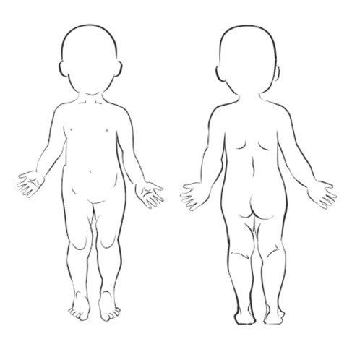 | ☐ | Abrasion/Scrape | ☐ | Eye Injury
 | ☐ | Allergic reaction (not anaphylaxis) | ☐ | Infectious disease (incgastrointestinal)
 | ☐ | Amputation | ☐ | High temperature
 | ☐ | Anaphylaxis | ☐ | Ingestion/inhalation/insertion
 | ☐ | Asthma/respiratory | ☐ | Internal injury/infection
 | ☐ | Bite wound | ☐ | Poisoning
 | ☐ | Bruise | ☐ | Rash
 | ☐ | Broken bone/fracture/  dislocation | ☐ | Respiratory
 | ☐ | Burn/sunburn | ☐ | Seizure/unconscious/convulsion
 | ☐ | Choking | ☐ | Sprain/swelling
 | ☐ | Concussion | ☐ | Stabbing/piercing
 | ☐ | Crush/jam | ☐ | Tooth
 | ☐ | Cut/open wound | ☐ | Venomous bite/sting
 | ☐ | Drowning (non‐fatal) | ☐ | Other (please specify below)
 | ☐ | Electric shock | ☐

Action Taken
Details of action taken (including first aid, administration of medication etc)
Did emergency services attend?
Was medical attention sought from a registered practitioner / hospital?
If yes to either of the above, provide details
Have any steps been taken to prevent or minimise this type of incident in the future?

Notifications (including attempted notifications)
 |  |  |  |  |  |  |  |  |  | Time |  | Date
Parent/guardian
Responsible Person In Charge
Approved Provider (if applicable)
Regulatory authority (if applicable)
(Shine Bright EYM Central Office to Notify Central Office to Notify DET)
Parental Acknowledgement
I |  |  |  |  |  | (name of parent/guardian/authorized person)
have been notified of my child’s
Signature |  |  |  |  |  |  |  | Date
If parent does not collect child on the day, parent to sign below at their earliest opportunity.
Parent Name |  |  |  |  |  |  |  | Date
Signature
Parent Comments/Feedback
Additional notes and Actions
Child’s Teacher to make a follow up phone call to child’s parents and any other parents involved within 24 hours to touch base and ask how they are and if they would like to raise this as a complaint. Teacher to record conversation here and sign and date
Signed Teacher |  |  |  |  |  |  | Date
Name if unable to sign doc

